**Assigned: Wednesday, September 21st** David Schmidt

**Due: Friday, September 30th by class time.**

**20 points**

**Objective: Use the algorithmic constructs of selection and iteration.**

A. Do all of the “Let’s Try It” exercises in Chapter 3. You should write the output into the blanks provided. The first one has been done for you as an example.

1. p. 82 False, True, True, True, True, False, True, True, False

2. p. 83 True, False, True, True, False

3. p. 85 False, True, False, True, False, True, True, False

4. p. 86 False, True, False, False

5. p. 88 True, True, True, True, False, False, False, False

6. p. 91 You have to have if and else on the same indent; otherwise, it won’t work.

7. p. 93 Sophomore.

8. p. 94 You need to switch grade to credits; otherwise, it won’t work.

9. p. 98 The first program shows the last number while the second one shows all of them.

10. p. 99 The first program went into an infinite loop, the second one didn’t work because you took away the line that had current equals current plus 1, and the third one just showed the beginning of n, or 10.

B. Answer questions 4, 6, 8, 10, 12, 15, 17 and 18 on pg. 118-120 of your text. You should retype the question prior to answering it in this MS Word doc. On questions 15, 17 and 18, you should test your code to make sure it works in the IDLE Python programming environment.

C. Classic Computer Science: Write a program that lets you type in a series of numbers and then tells you how many of the numbers were negative and how many were positive. You should stop asking for numbers when 0 is entered. Here is a sample run:

Please type in a series of numbers. I will tell you how many are positive or negative.

Enter a number: 10

Enter a number: 5

Enter a number: -3

Enter a number: 4

Enter a number: 0

There were/was 3 positive number(s).

There were/was 1 negative number(s).

D. Do M11 (The Sage Modification Program). I will ask you to demonstrate this program for me in class on the due date. Please be creative (as asked) and make the responses your own! Here is an (OLD) YouTube video about the original Eliza: <https://www.youtube.com/watch?v=4sngIh0YJtk>

B. 4. The Boolean data type contains two literal values, denoted as True and False, in Python.

6. Which of the following relational expressions evaluate to False? D.

8. Evaluate the following Python expressions. a) 24 == 24 True b) 28 != 24 True

10. Evaluate the Boolean expressions below for n = 10 and k = 20.

a) False

b) True

c) True

d) False

e) True

12. Evaluate the following Boolean expressions for num1 = 10 and num2 = 20.

a) False

b) True

15.

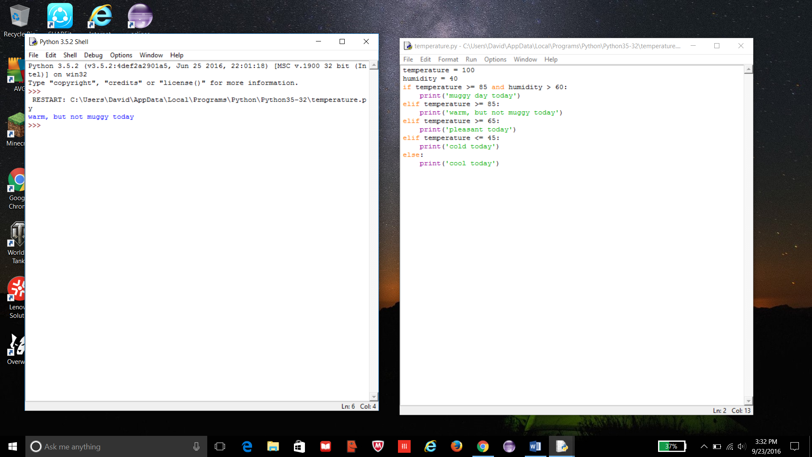

17.

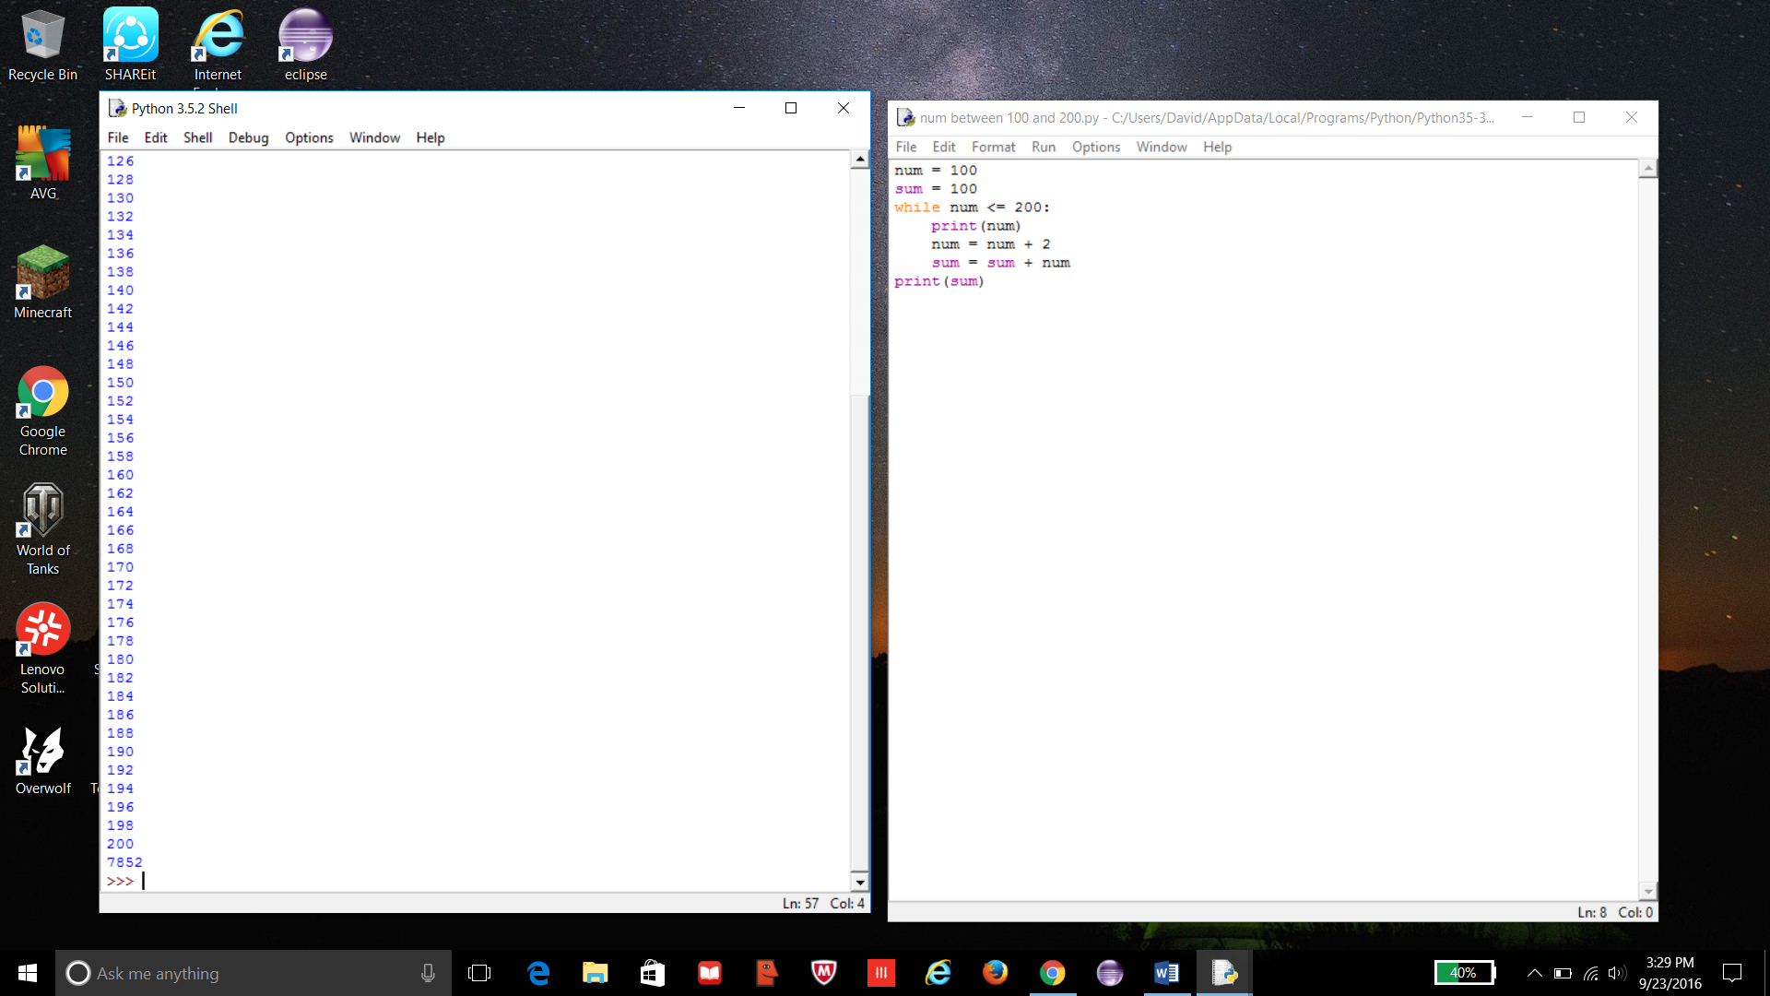

18. Print doesn’t need to be indented, it shows ‘Enter first number: ‘more than once, and num should equal num, not input.

C.

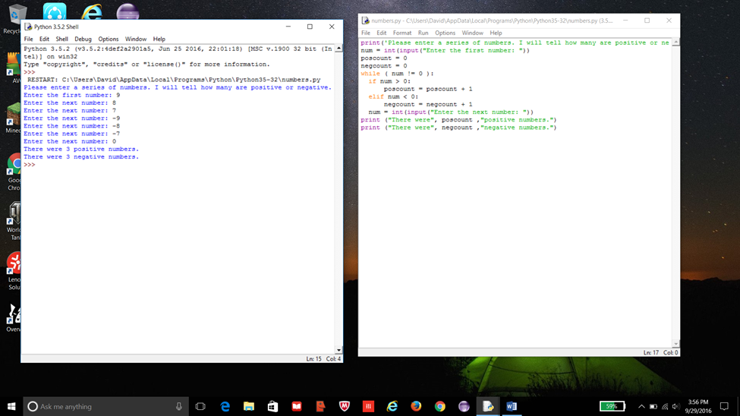

D.

